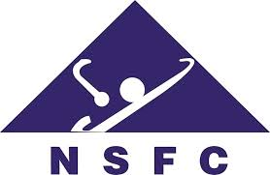

NSFC-BHAEC化学新前沿联合研讨会
NSFC-BHAEC Joint Symposium on Chemistry for New Frontiers

Registration Form for Mainland Participants

1. Title

2. First Name:

3. Last Name:

4. Job Title / Position

5. Institution / Company:

6. Corresponding Address:

7. Email Address:

8. Do you need an official receipt? | Yes / No
9. Do you have any diet restriction? If yes, please specify. | Yes / No  Specifications:
10. Theme | - New Frontiers in Synthetic Chemistry  - New Frontiers in Chemical Biology  - New Frontiers in Functional Materials  - New Frontiers in Physical Chemistry and Computational Chemistry

Please return your completed registration form by email to vkylo@hku.hk on or before 30 June 2019.

Thank you very much.

